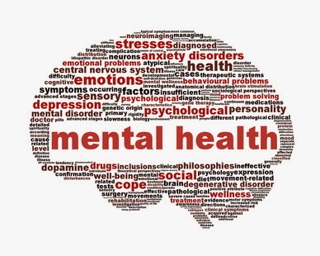JJ O’Neill is hosting a guest speaker for our community  Wednesday, January 16, 2019  Supporting Mental Health with Nutrition  Can nutrition help our mental health? There are vitamins, minerals and nutrients that are needed to support our mental health and support our nervous system. If you are deficient in certain nutrients, symptoms of mental health such as stress, anxiety, depression, mood changes, insomnia, hyperactivity and ADHD can worsen. Come and learn about these key nutrients, and the foods and supplements that have these nutrients. Presented by Tricia Cammaart. Tricia co-owns Zeal Health and Fitness Studio. She has a BSc in Biology, is certified as a nutritionist with Precision Nutrition and is currently taking her diploma as a Registered Holistic Nutritionist. | 6:30-7:30 PM  ────  FREE Childcare  ────  FREE Snacks  ────  FREE Coffee  ────  Join us in the gym on January 16th to start the new year off with a helathy mind and body.

